# Remote workshop general tips

Performing a remote workshop can be more challenging than a face to face workshop for a number of reasons. But it can have advantages as well, like being able to service client teams scattered geographically without requiring travel. It can also serve well in times of social distancing.

Generally speaking, the less students in a workshop (and the less CPD workshop cluster environments you have to juggle) the more smoothly the event will go. This allows for greater attention to each student and minimizes the potential for having simultaneously occurring serious problems with different students doing labs.

A general rule of thumb you might want to practice is to have at least two IBM proctors for a typical 10 student workshop. Having more proctors is better of course.

# Webex Meetings

Most remote workshops are done using the straightforward Webex Meetings approach.

The workshop is scheduled like any other Webex meeting, with invitations sent out via email. All instructors and participants dial to the Webex meeting. Presentations are delivered via sharing feature.

The main reasons for using Webex Meetings are:

1. It is an interface every IBMer has used and is proficient with
2. It is a free service provided by IBM.

## **Doing labs via Webex Meetings**

Labs are done together with each student going to their assigned cluster environment, each of which has its own URL.

If a problem occurs, the student can speak up verbally, raise their hand or chat via the Webex Meetings UI to get a proctor’s attention.

If the proctor needs to see the student’s screen to help them out, that can be done one of two ways:

1. *Student shares his screen in the Webex Meetings screen and the proctor looks on while the student shows the problem.* This approach has a potential benefit that if the other students wish to, they can look on while the problem is being solved to learn from or even pitch in to help. The downside is that some IBMers think this could embarrass a shy student who thinks their problem is silly, which could prevent them from asking for help.
2. *The proctor logs into the student’s screen in another browser window using the assigned URL to watch the student show the problem there.* This approach has the benefit of allowing the proctor to take control of the UI and fix the problem for the student.

# Webex Training

Webex Training is designed for doing events with activities similar the remote workshop. The main reasons why you might want to use Webex Training are :

1. It is a free service provided by IBM
2. It has breakout session capability
3. It has whiteboarding capability
4. It has a very controllable invitation capability

Since many IBMers are unfamiliar with using Webex Training, I will outline quickly how to get a session started. Log into the Home page of your Webex account and then:

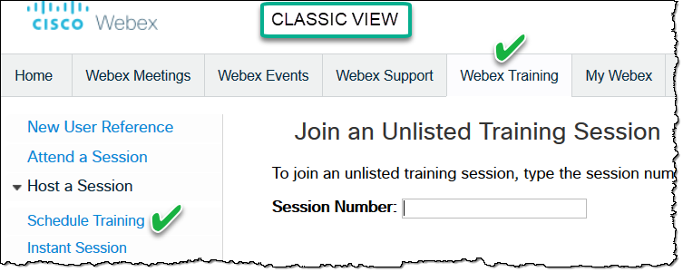 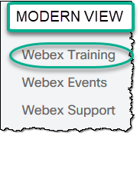

Tip: You can practice using the Webex Training interface by choosing the “Instance Training” rather than scheduling one.

For official docs on this:

<https://w3.ibm.com/help/#/article/webex_training/schedule_webex_training>

## **Doing labs via Webex Training**

Labs are done together with each student going to their assigned cluster environment, each of which has its own URL.

If a problem occurs, the student can speak up verbally, raise their hand or chat via the Webex Training UI to get a proctor’s attention.

If the proctor needs to see the student’s screen to help them out, that can be done one of three ways:

1. *Student shares his screen in the Webex Training screen and the proctor looks on while the student shows the problem.* This approach has a potential benefit that if the other students wish to, they can look on while the problem is being solved to learn from or even pitch in to help.
2. *The proctor logs into the student’s screen in another browser window using the assigned URL to watch the student show the problem there*. This approach has the benefit of allowing the proctor to take control of the UI and fix the problem for the student.
3. *The proctor creates a breakout session for the student and any others who may want to help with the problem*. They can go to that breakout session and solve the problem similar to the first method, but in this case only those people can participate.

## **Webex Training Workshop Tips**

### Use a Workshop Manager

Consider using a remote Workshop Manager whose sole focus is to run logistics of the event. e.g.

* Set up the event (which allows them to retain by default all the key functions needed)
* Create the invitations
* Assign the cluster URLs or IDs to each student
* Create and run polling questions
* Introduce the speakers
* Run the breakout sessions
* Track the time for presentations and labs (per the agenda) to keep the workshop running on time

### Use Slack

Consider using Slack for all the IBMers to communicate behind the scenes during the workshop.

### Formalize the event

* Name your event, and set a password, date and time. Additionally, if you require registration then all attendees will get a unique sign on.
* Set up the presenters and/or proctors ahead of time when you schedule the event which allows easier passing of controls during.
* Consider asking the group to mute themselves at the beginning of the event. (If the host mutes everyone, then the attendees cannot unmute themselves.)
* Under *Participants* in the top menu, select *Assign Privilege* and then click on *Communication* and then check the box for *Chat with All Attendees*.

### Breakout session tips

* To create Breakouts, click on *Breakout* in top menu -> then click *Breakout session assignment* -> then create a number of breakout rooms. When ready, click *Start Breakout sessions*.
* Only the Host (the one with the Webex ball next to their name) can open and close breakout sessions, so the appropriate person should take control back before lab time to create breakout sessions.
* Make the student the *presenter* in the breakout session so they can immediately begin showing their screen to a proctor.
* Remind participants they will have to accept the breakout room invite, then accept the message to change their audio.
* Remind participants if anyone shares their screen in breakout, they need to end screen sharing before they can leave the breakout and return to the main room.
* During breakouts, nothing can be going on in the main (shared) session. Chat still works in the main session, but there is no screen sharing. If students have a question during breakout time - ask them to post it in the chat and then you can assign them to a breakout with a proctor.
* Host can force all the breakouts to close by selecting *End Breakouts*; this sends a pop up and tells the participants that the breakout is ending.

See DTE presentation and video for more tips on using Webex Training:

<http://ibm.biz/dte-digital-workshop-prez> (NOT WORKING)

<http://ibm.biz/dte-ditigal-workshop-video> (NOT WORKING)

# Other potential workshop tools

Some have opted to use other so-called webinar tools besides Webex. While I will not discourage it, none of them that I know of are free for conducting regular remote workshops of any size and length. Some examples include:

## **Zoom**

One IBMer said he used Zoom effectively and was easy to set up. He effectively used the breakout session capability which he said he preferred over Webex Teams because he could have multiple breakouts while still sharing in the main session.

See: <https://zoom.us/meetings>

Disclaimer: I am NOT making an official recommendation that you use Zoom. I am only mentioning that others have used it. Since Zoom has had reported problems with security and is not an official tool for IBM, I can only tell you that it has been used by others. If you DO choose to use Zoom, then please refer to this LinkedIn post by Paul Zikopoulos that tells you how to secure a Zoom meeting:

<https://www.linkedin.com/posts/paul-zikopoulos-4323607_zoom-covid-activity-6655615037987700736-zOuW>

## **ON24**

Another IBMer uses ON24 due to its collaboration with IBM and in particular its Marketing automation platform tie-ins. However, it does not have the same advantages as Webex Teams in the space of breakouts, whiteboarding, etc. So, ON24 was used for the presentation portion of the workshop to gain marketing information, and then he used Webex Teams for performing the labs.

See ON24 Best Practices [here](https://w3-connections.ibm.com/wikis/home?lang=en-us#!/wiki/W9ac68e6fee73_4cf5_b54d_1e95685e4ee4/page/DRAFT%20-%20ON24%20webinars%20best%20practices).

See IBM reference [here](https://www.on24.com/resources/assets/video-ibmcloud/).

Documented by: Burt Vialpando and Kent Rubin – September 22, 2020